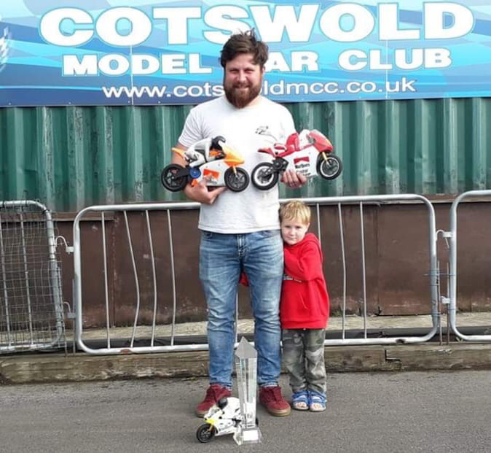
Cotswold GP / Dez Chand Memorial Meeting 2019

Ross Bartlett makes it a clean sweep at the Cotswold GP – Dez Chard Memorial Meeting taking a well deserved win in 1/5th Open Class with a win and second in the two finals and a win in both finals in the 1/8th Class.

Overview
I don’t think we have another event on the calendar which the members look forward to more, the relaxed environment, different racing rules, 80’s music and camp fire / barbecues all round.
The Cotswold GP has for several years also double up as a Memorial Event for the late Dez Chand. A person who several will remember but some who will not. Dez was an outgoing individual who always welcomed newcomers with a smile and a joke, who would then set about making sure you had a great weekend racing. Something we should always remember as we go forward.
Those who decided to make an early start and arrived at the track on Friday evening were greeted with heavy rain and wind, meaning pitching tents and campers was extremely challenging.
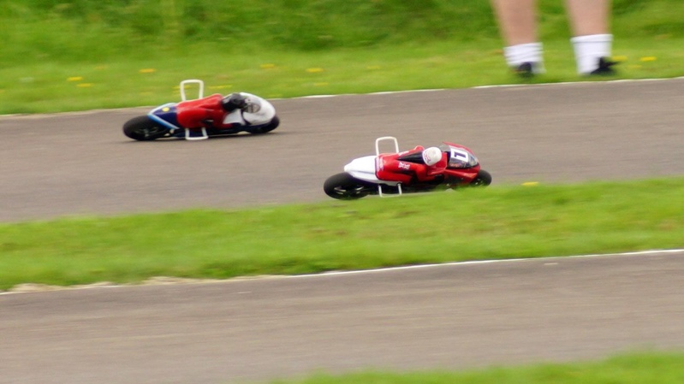
Saturday morning provided a wet and somewhat greasy track surface which proved a challenge for all. As the afternoon approached the rain was long gone and the wind and sun dried the track to almost a perfect surface.
This pleasant change allowed everyone to pack the wet bike away and home their thumbs s to the improved conditions. For those arriving later in the day had the best of the conditions but practice was going to be cut short due to the Section Conference at 5pm.

Qualifying
Sunday morning was not a good start , as people surfaced from their overnight slumbers it was evident that the weather gods had decided to treat us all with rain, someone in the Section has definitely done something to upset them!
Being the GP, a more relaxed environment was applied, racing would get underway when all were ready, keeping in mind we all wanted to complete the full programme of 4 qualifying and 2 finals. Being non-national event open class racing was the order of the day. The inclusion of 1/8th racing also adding to the spectacle.

As everyone assembled it was agreed to start at 9:30 on a wet track. Round one underway, with the first of 5 heats, 8 minute qualifying and 10 minute finals, it was going to be a long day. Unfortunately for some the wet weather caused several electrical errors with esc faults being the most common, the Nitro runners did not have a trouble free day the fuel contamination being the most likely culprit for some uncharacteristic failures.
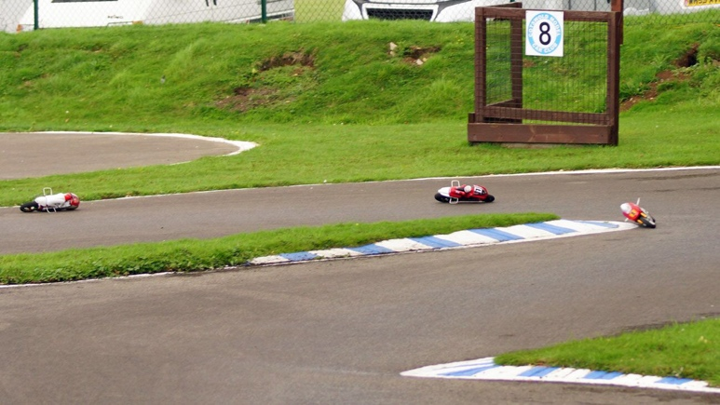
As the morning progressed and with the track conditions improving times started to tumble, Peter Vater heading the 1/5th Open Class and Mark Plested and Alex Wynn showing their skills in 1/8th. For this event, FTD was a new qualifying system, meaning everyone had to concentrate to maximise their finals grid position.

By the end of Q3, it was evident that the changeable weather has mixed the expected order, whilst Peter was super quick over one lap with his Superbike format his 8 minute run was still within reach of some of the Stock Class runners which was going to be an interesting spectacle for the finals. In Nitro class the field could be covered by a few seconds which again meant finals were going to be close. The new 1/8th class, with a mix of standard and gyro runners indicated that both could run competitively side by side. With Ross Bartlett being consumed by the electric problems on his 1/5th Stock bike he was banking on a one run do or die to maximise his grid position.
As Q4 approached the track was dry, a light breeze with the sun shining, perfect conditions for everyone to finally put in their best run. Peter V still heading the 1/5th class with FTD , Ross B finally got rid of all his woes to put in a stunning run, just a few seconds off FTD, even I popped up to pole in the B having held the wooden spoon all weekend; pole in C Final saw Karl Boak make good his excursion into the Electric Class.
With Alex W, Mark P and Dave Hall all putting in credible runs in 1/8th Class, all showing that this class is not out of place on UK tracks.
MotoGPn appeared to be running trouble free no matter what the weather threw at them, how wrong could we be, water can get anywhere, even in the fuel as Ken Gospel will testify. Even taking this into account, the Nitro runners really are a pleasure to watch. Karl B and John Veal swapped fastest time on several occasions, Karl eventually taking a well earned FTD and pole position.

Finals
Finals were posted and everyone prepared for the off but that’s when things started to go wrong. The skies suddenly darkened and no one could tell, even when on the line, if the rain would start or hold off. With some finals running in full rain, others in bright sunshine it really tested the skills and a fast Bike didn’t mean you were going to finish first.

The C final showed that perseverance through the weekend does pay off, Martin W taking overall with two Second places with excellent performances for Mark Williamson , Karl Boak and Paul Fry. A special mention for John Williams in his first event, showed great promise for the future and when he forgets about 1/12th driving he will definitely be one to watch.

B Final was probably had the worse of the weather over the two runs but didn’t spoil the enjoyment with Dave R topping the table with a 1st &. 2nd. Special mention for Dave H who had the biggest smile of everyone taking the win in the second final.

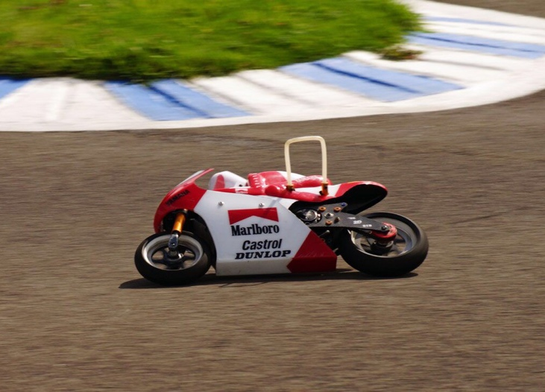
A Final, this was to be the highlight for everyone present, would Peter V walk it or would anyone throw a spanner in the works. Even the marshals were enthralled by the battle and the term “Tortoise and The Hare” springs to mind. Peter V was fast but Ross B was pretty quick. Final one saw Peter make a mistake and Ross was past, Ross would then make a similar mistake and Peter was through. This was repeated from tone to tone with Peter taking the win by just over one second. Final 2 was stuff of the same, this time however, Peter made an early mistake which made the next 10 or so laps a please to watch, running consistently in the 27 Sec in the process passing Ross who himself made an error which dropped him down the field. It was now Ross who turned on the style and punch in quick laps to regain his position close to the head of the pack. It did look that Peter was going to take the win but at approx 8.5 min Peter came together with two back markers which upset the flow allowing Ross to run away for the win, in the process taking top spot and the Dez Chand Trophy.
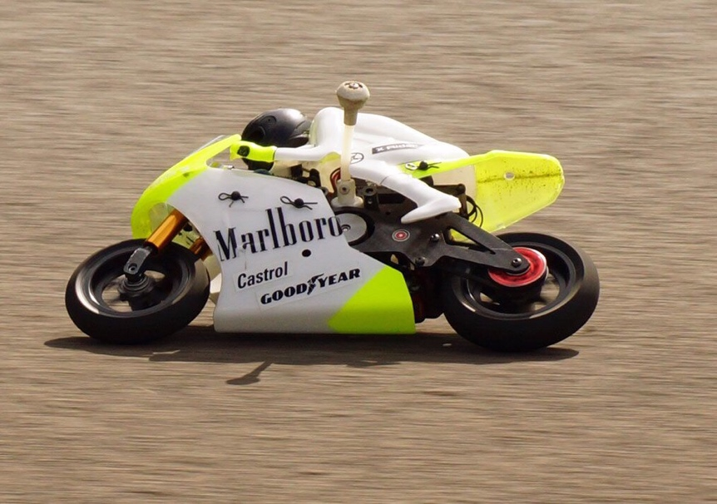

Following these two finals, some might think Ross B would have exhausted the tank but this couldn’t have been further from the truth, putting in two stunning runs from the back of the grid to make it a clean sweep with Mark P keeping him honest in both finals.

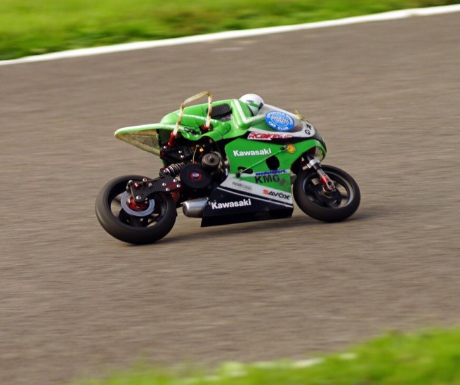
MotoGPn finals were both close affairs with Karl and John swapping the lead throughout final 1 but suddenly John was nowhere to be seen, with his bike stopping on the track it meant Karl ran out the winner. Final 2 started in similar fashion with Karl and John swapping the lead, John eventually got in the groove holding the lead, lap after lap. Karl was not going to give up and started to put in some consistently quick laps finally overcoming John to take the win, a really close final.

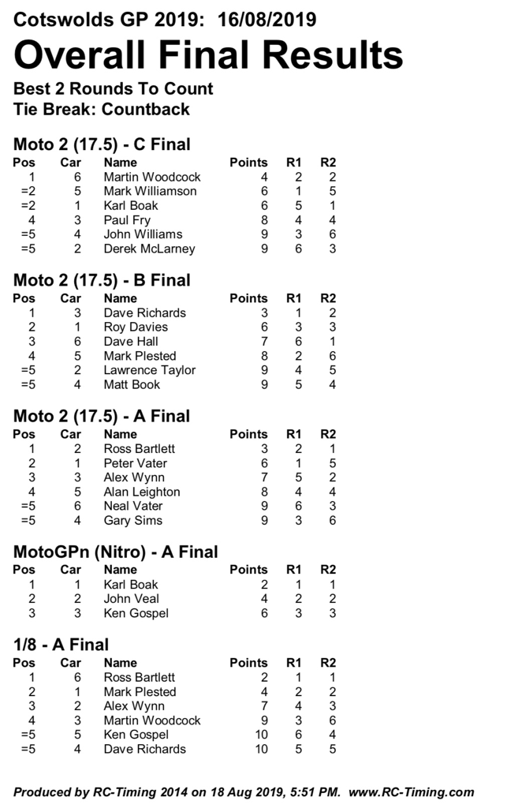
In conclusion the results almost become secondary to what turned out to be a challenging but a fantastic meeting. The true measure being the smiles during and after the event which was present on the majority of attendees.

Thanks must go to the Cotswold Club for welcoming us to the circuit again, the those who made the event happen, Richard Gorringe in Race Control for keeping us all inline and volunteering when we were short of a marshal and lastly everyone who attended and make it a great meeting.

