

BRCA Bike National Round 3 at Cotswold 2019

Another dominating performance by Peter Vater in Moto2 with him taking TQ and both A Final wins, which puts him firmly at the top of the Championship Table after three rounds.

Moto2 Podium
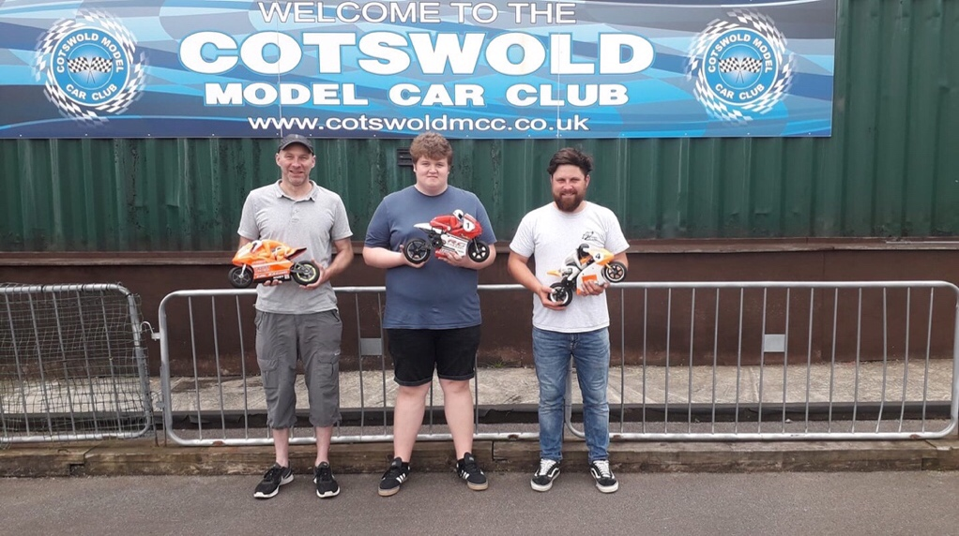

The weekend of the 22/23rd June 2019 saw the Bike National Series move on to the Cotswold MCC Track at Kemble Airfield. A good weather forecast brought a good turnout for the weekend with the majority taking full opportunity of Saturday practice in glorious sunshine. Tyre choice for the weekend looked to be a simple task with GRP M3 or Roadie med/hard being the only choice.

Sunday morning was warm if a little overcast and as many had stayed locally or camped by 8am the full entry was trackside. The planned short practice session for the few who couldn’t make Saturday soon got underway to ensure Drivers briefing could take place as scheduled.

Drivers briefing completed, everyone was enthusiastic to get underway. With three heats everyone was hoping for a relaxed race meeting with 4 qualifying rounds for everyone along with the 2 point scoring finals ahead of us.

Qualifying
On completing the first round of qualifying the results quickly showed that the grading of the heats were very accurate with top qualifiers were generally in heat order. This made for very competitive racing throughout the field. It was good to see one of the newest member to the Section, Paul Fry, get to grips with the flowing Cotswold Circuit on his first visit and dramatically reducing his qualifying time by Round 4, well done. The recent availability of replacement rider fairing mouldings have had a positive effect on the equipment presentation and the lack of Gaffa Tape etc and missing heads makes for impressive photos and videos. Well done to everyone and keep it up.

As the qualifying rounds progressed it was soon evident that it was going to be a close thing for those hoping to make the top final. A group of 7 drivers putting in respectable times and fighting for the top 6 positions with the rest of us fighting for the “also rans”. Who was going to be the “bridesmaid “ and top the B.
Qualifying allowed everyone to push the limits of both thumbs and equipment with several paying the ultimate price of loosing that third quick lap. Two areas of the circuit appeared to be the limiting factor for those three consecutive laps required. The sweeping chicane in the middle of the track and the pinch point at the start of the pit straight.

Home advantage at first didn’t seem to be help as all the front runners struggled to find that perfect line. Some tried the obvious “miss them altogether” and cut across the grass or launch it off the curb and hope it lands on the wheels. It was even suggested that Ross had installed a ski jump on the pit lane chicane.

In the final analysis most found their “happy line” and recorded some very quick laps with the top three from the previous National topping the charts.

Qualifying Table
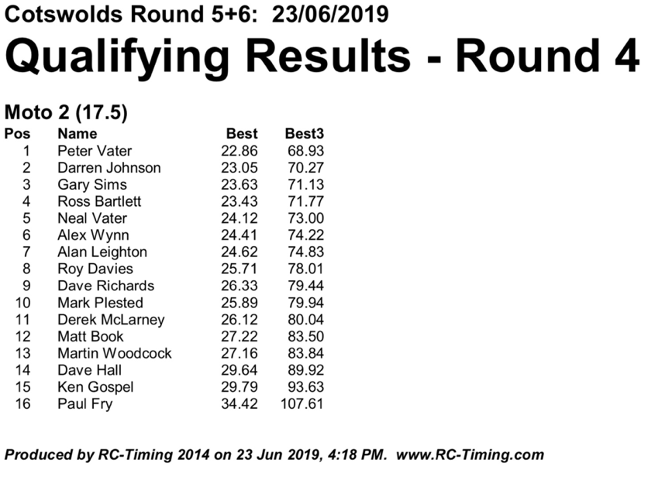
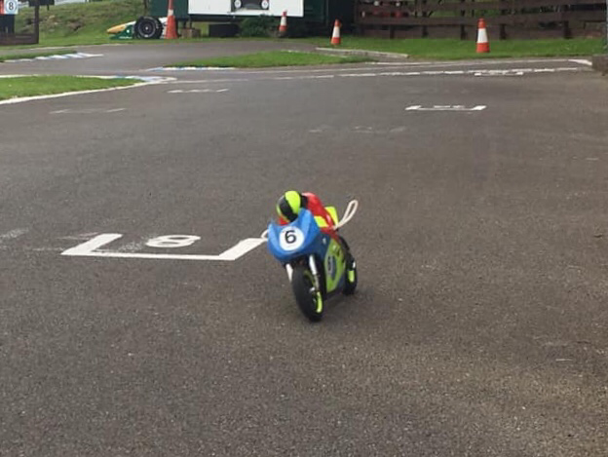
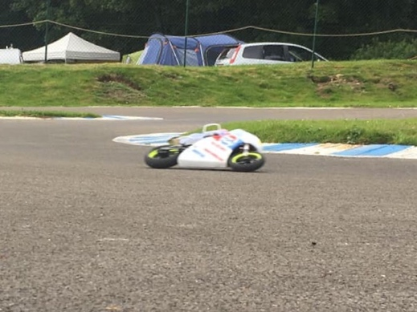
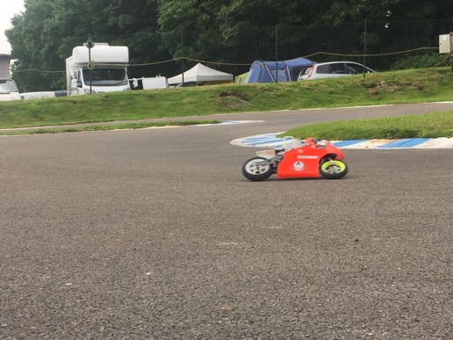
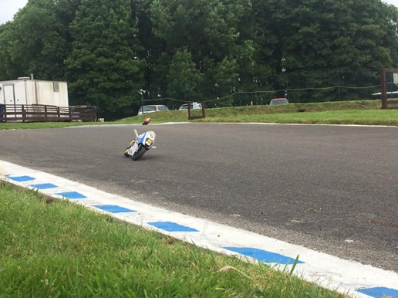

With qualifying complete we took a short lunch break to refuel and prepare for the upcoming finals.

It was good to have a visit from the Cotswold Club Chairman (Ian Coates) who rolled up on his Honda CBR Fireblade showing interest in the Bike Scene. Unfortunately our Section Scrutineer (Julie) excluded him from the meeting as neither his motor or battery appeared on any of the BRCA lists.

Finals
As the finals got underway the clouds started to thicken; did that matter? Not one bit! Wet or dry, Bikes will run.
All bike finals require a starter who’s task is to smoothly launch each bike in a timely manner, a big responsibility considering a bad start could loose more than half a lap, 12/14 Sec. which is so difficult to recover. Thankfully we have some expert hands with Alan L and Ross B taking the responsibility. Good clean starts in all finals, first task complete.

Both the B and C finals produced clean and competitive runs, Martin W taking C Final overall on Qualifying position from Dave R having taken a Final each, in both cases being a lap or two ahead of the rest . Similarly Alan L took B Final overall having shared Finals with Roy D.

In the A Finals Peter V smoked them in each final, actually leaving rubber on the track. Even with this tremendous speed he didn’t get it easy, being kept honest by Darren and Ross in each final, but in the end he was just too quick and took both finals producing the only 25lap runs of the weekend. Darren and Ross have taken a 2 place each shared the podium.
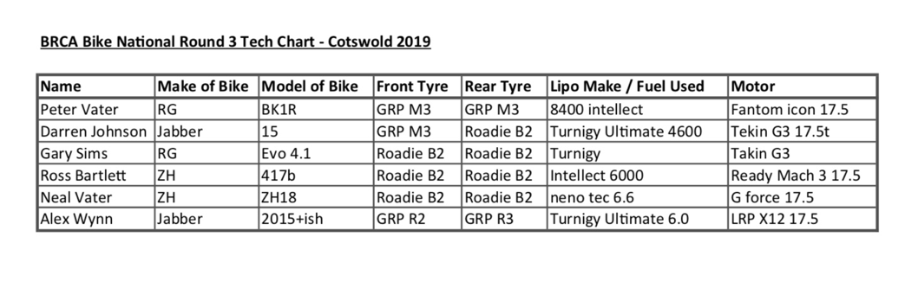
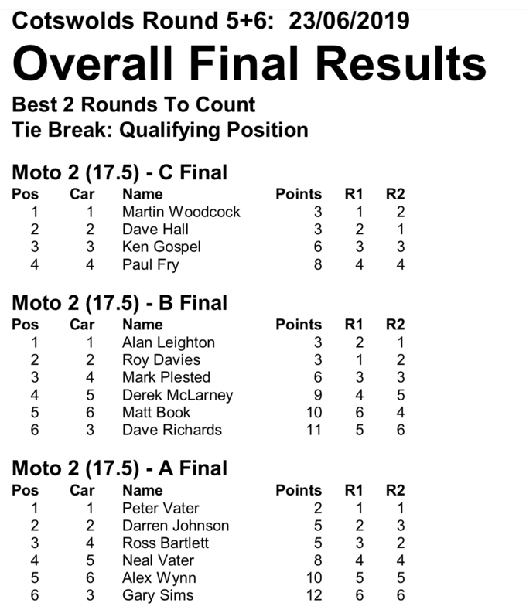

In closing, it is worth noting that unfortunately for this meeting we were not going to be running MotoGPn as several regular attendees were absent for family commitments, we hope that the class will attract the regular participants back at future Nationals. Thankfully our remaining contingent of Nitro runners were able to join the electric class.

With the absence of John Veal, our resident Section photographer, I have to thank Ross, Neal and others for stepping into the firing line with their phones to provide all the photos, also have to mention our newest member for producing a short video which captures some enlightening images of our form of RC and well worth a watch, thank you all.
Video link: https://m.youtube.com/watch?feature=youtu.be&v=wqk9QV3JQhc

Cotswold MCC

Thanks must go to Cotswold MCC (as the larger people would say), probably the best track in the country for welcoming us again this year and we hope that continues in the future.

Prepared and presented in A1 condition.
