JC RACEWAY FACT SHEET 2018

TRACK LOCATION – Southwood farm , Neen Sollars, DY14 0AE.
Please be very mindful especially with a large vehicles or caravans to drive into Cleobury Mortimer on the A4117 onto the Tenbury Road for 1.25miles to the track. The other routes should be avoided due to being single track. See Map below.
52°21'51.1"N 2°30'10.3"W 52.364181, -2.502871
(Please confirm coordinates are correct to the map before setting off)
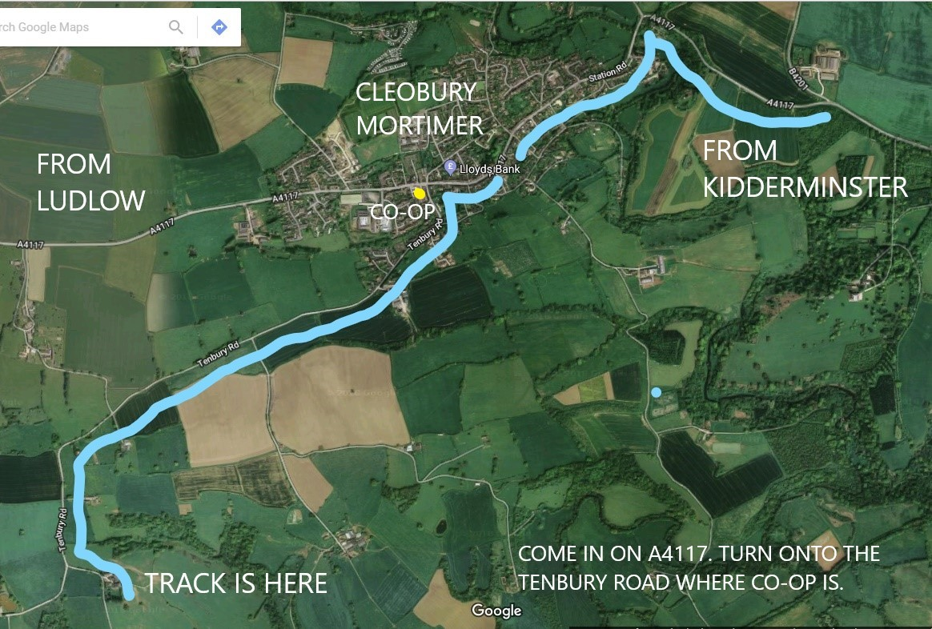
The track is a purpose built all dirt track to BRCA spec run clockwise with various features from Jumps, rhythm section, step downs, Ski Jump and long straights, off camber and huge elevation changes.
Scaffold rostrum with roof and raised pitlane. Check JC Raceway Facebook for lots of track pictures. Plenty of outdoor pitting area and indoor if needed.

Camping available free of charge for duration of the event.
Drinking water on site.
Food available trackside at the buggy national by carnival Pizza.
No smoking in certain parts of the location, signage is displayed so please observe.
Porta loos for men and Women.
Dogs allowed but must be kept on a lead.
Generators off before 11pm-7am
All litter to be either taken home or placed in the bins provided, extra bin bags available just ask.

Respect the local community please and drive carefully as the roads can be very dangerous due to heavy farm machinery.

LOCAL FACILITIES
LOCAL PETROL GARAGE / CO-OP EXPRESS SHOP - High St, Cleobury Mortimer, Kidderminster DY14 8DR, OPEN 6AM – 11PM - 7 DAYS.
CAFÉ AND TAKEAWAYS in Cleobury Mortimer town 1.5 mile from the track.
LOCAL POLICE - Talbot Square, Cleobury Mortimer, Kidderminster DY14 8BQ, Emergency number 999. Non-Emergency number 101.
NEAREST MINOR INJURY UNIT - Bewdley Rd, Kidderminster DY11 6RJ. Tel – 01562 823424 (first aid kit in race control)
CLEOBURY MORTIMER CHEMIST - 01299 270219, Vaughan Rd, Cleobury Mortimer, Kidderminster DY14 8DB. Open Friday 8-6pm, Saturday 8-1pm.
ACCOMODATION
TRAVELODGE kidderminster approx 25min from the track - website
PREMIER INN Kidderminster approx 25min from the track - website
MERCURE hotel Kidderminster approx. 20min from the track - website
WEATHERSPOONS Bewdley approx 15-20min from the track – website

MUG HOUSE PUB Bewdley approx. 15-20min from the track.
01299 402543, 12-13 Severn Side N, Bewdley DY12 2EE.

THE KINGS ARMS HOTEL Cleobury mortimer – 5min from track
01299 271954, 6 Church St, Cleobury Mortimer, Kidderminster DY14 8BS.

Various B&B and Guest house within a 20min drive of the track.

Look forward to seeing you.
Thank you

