Remote World Model Car Club
Slough
Factsheet (2020)
Website – www.remoteworld.co.uk
Facebook - https://m.facebook.com/pages/Remote-World-Model-Car-Club/147585238744953
Contact us
Email - rallyx@remoteworld.co.uk
Or message through Facebook page
Track Location
Upton Court Park
Datchet Road Entrance (Off B376)
Slough
Berkshire
SL3 9AL (this is closest postcode to the gate and is along the road opposite the entrance)
Entry is via a single track service bridge that crosses the M4 motorway. Once over the bridge, turn right along tarmac roadway. Bear right again at the fork onto gravel track and continue for 200 yards. Track is located ahead on the left. Please observe 10mph speed restriction within the park and give way to walkers and cyclists who also use the roadways and tracks within the park.
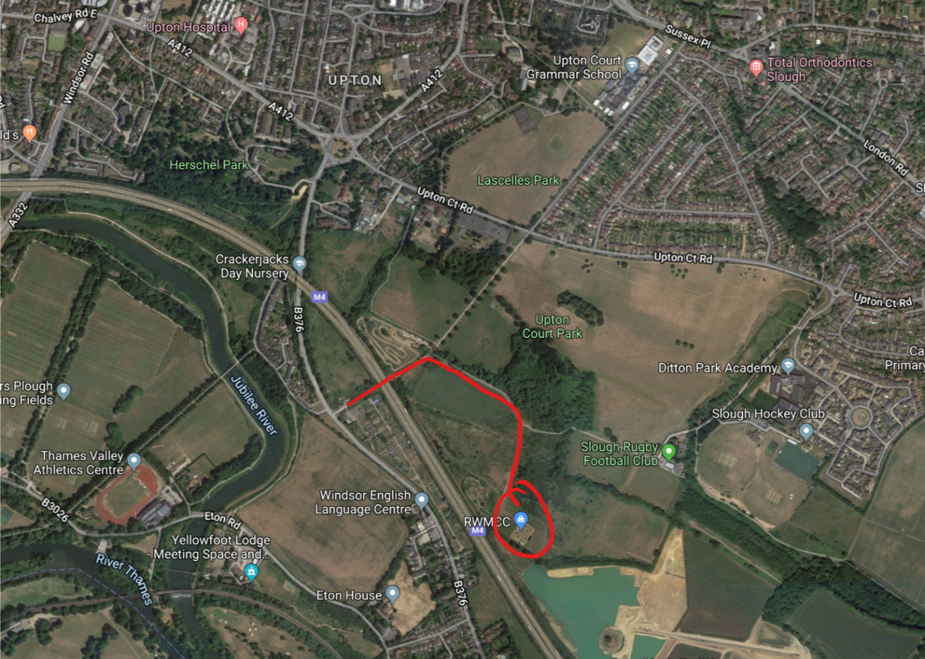
The gate opening times are restricted and access will only be available from 15:00 on Friday 18th Sept.
The gate will be locked each night at 22:00, and re-opened at 07:00 in the morning on Saturday 19th and Sunday 20th.
Food will be provided by burger van on Saturday and Sunday.
Free camping is available with water and toilets on site.
Caravans / motorhomes are requested to park outside of the fenced area to maximise space for pit tents within.
Note, the track is located next to the M4 motorway and is under the flight path for Heathrow airport, so can be a little noisier than other venues.
To respect all campers, generators and loud music etc shall be off between 11:00 - 07:00.
Track is of all dirt construction and runs anti-clockwise. Large purpose built rostrum with raised concrete pitlane and adequate pit space and warm up table. We operate a simple 1-way system of entry / exit into pitlane and rostrum.

Hotels:-
Travelodge Slough
Landmark Place,
Herschel St,
Slough SL1 1PG

Copthorne Hotel Slough-Windsor
Cippenham Lane,
Slough SL1 2YE

Holiday Inn Express London - Heathrow T5
Cippenham Lane,
Slough SL1 2YE

Premier Inn Slough
Uxbridge Road,
Slough. SL1 1SU

Plus many more hotels and local B&Bs.

